***Binary Search Tree problems***

1. **Recover Binary Search Tree**

You are given the root of a binary search tree (BST), where the values of **exactly** two nodes of the tree were swapped by mistake. *Recover the tree without changing its structure*.

**Example 1:**

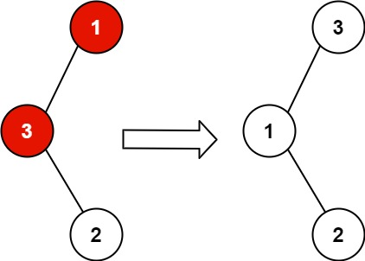

**Input:** root = [1,3,null,null,2]

**Output:** [3,1,null,null,2]

**Explanation:** 3 cannot be a left child of 1 because 3 > 1. Swapping 1 and 3 makes the BST valid.

**Example 2:**

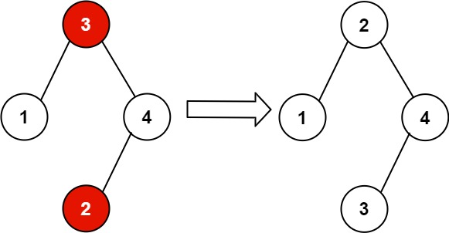

**Input:** root = [3,1,4,null,null,2]

**Output:** [2,1,4,null,null,3]

**Explanation:** 2 cannot be in the right subtree of 3 because 2 < 3. Swapping 2 and 3 makes the BST valid.

**Constraints:**

* The number of nodes in the tree is in the range [2, 1000].
* -231 <= Node.val <= 231 - 1

1. **All Elements in Two Binary Search Trees**

Given two binary search trees root1 and root2, return *a list containing all the integers from both trees sorted in****ascending****order*.

**Example 1:**

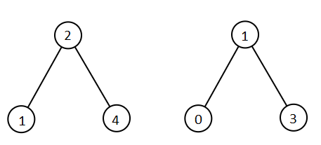

**Input:** root1 = [2,1,4], root2 = [1,0,3]

**Output:** [0,1,1,2,3,4]

**Example 2:**

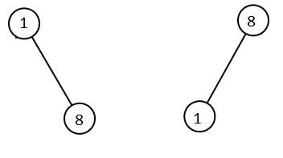

**Input:** root1 = [1,null,8], root2 = [8,1]

**Output:** [1,1,8,8]

**Constraints:**

* The number of nodes in each tree is in the range [0, 5000].
* -105 <= Node.val <= 105

1. **Find Leftmost and Rightmost nodes for a given node:**

Given a preorder sequence of the binary search tree of **N** nodes. The task is to find its leftmost and rightmost nodes.

**Examples:**

**Input :** N = 5, preorder[]={ 3, 2, 1, 5, 4 }

**Output :** Leftmost = 1, Rightmost = 5

The BST constructed from this

preorder sequence would be:

3

/ \

2 5

/ /

1 4

Leftmost Node of this tree is equal to 1

Rightmost Node of this tree is equal to 5

**Input :** N = 3 preorder[]={ 2, 1, 3}

**Output :** Leftmost = 1, Rightmost = 3

1. **Convert BST into Skewed Tree:**

Given a Binary Search Tree and a binary integer **K**, the task is to convert Binary search tree into a Skewed Tree in increasing order if **K = 0** or in decreasing order if**K = 1**.

**Examples:**

**Input:** K = 0,

5

/ \

3 6

**Output:**

3

\

5

\

6

**Input:** K = 1,

2

/ \

1 3

**Output:**

3

\

2

\

1

**Reference links:**

* 1. https://leetcode.com/problems/recover-binary-search-tree/
  2. https://leetcode.com/problems/all-elements-in-two-binary-search-trees/
  3. https://www.geeksforgeeks.org/find-leftmost-and-rightmost-node-of-bst-from-its-given-preorder-traversal/
  4. https://www.geeksforgeeks.org/convert-a-binary-search-tree-into-a-skewed-tree-in-increasing-or-decreasing-order/